**R Code for Examples in the book**

***“Statistics: The Art and Science of Learning from Data”***

**by Agresti, Franklin and Klingenberg, 5th edition**

**Chapter 2**

**Example 4: Health Value of Cereals – Dotplots**

## Reading in Sodium values:

sodium <- c(0, 340, 70, 140, 200, 180, 210, 150, 100, 130,   
 140, 180, 190, 160, 290, 50, 220, 180, 200, 210)

## Create basic dotplot:

stripchart(sodium, method = 'stack', pch=19, ylim=c(0,3), frame.plot=FALSE,   
 main = 'Dotplot', xlab = 'Sodium Content (mg)')

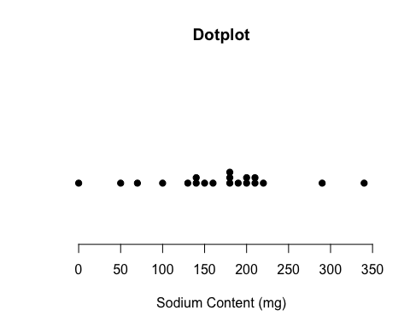

## You may have to resize the plotting window and then execute the command again for this plot to look nice. You may also have to try different values for ylim.

## A slightly better dotplot can be obtained with the ggplot2 library. To install it, type install.packages('ggplot2').

library(ggplot2)  
ggplot(data.frame(sodium), aes(x = sodium)) +   
 geom_dotplot() +  
 labs(x = 'Sodium Content (mg)', title = 'Dotplot',   
 subtitle = 'Sodium Content of 20 Breakfast Cereals') +  
 theme_classic() +  
 theme(axis.line.y=element_blank(),  
 axis.text.y=element_blank(),  
 axis.ticks.y=element_blank(),  
 axis.title.y=element_blank()  
 )

